Zoha, Hanaa, Sana & Ayla
cordially request the blessed presence of
____________________________________________________
at the Mehndi Ceremony of their beloved aunt
Saleha Mansoor
on Sunday, March 11, 2018
at 5:00 pm
Venue
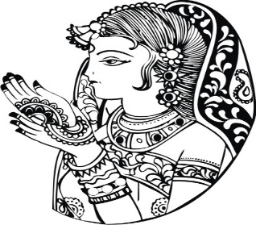
52 Sun Valley Drive,
Richmond Hill, ON L4S 2E4
R.S.V.P.
Fozia Mansoor: +1 647.477.9967
Talia Ahmad: +1 708.717.2610
IMAGES IN THE DOCUMENT CAN BE CHANGED (IF REQUIRED) TO THE IMAGES CHOSEN FROM OUR LIBRARY. PLEASE CLICK ON LINK BELOW TO BROWSE OUR LIBRARY OF IMAGES FOR MEHENDI CARD https://www.parekhcards.com/logos/Hindu-Invitation-Logos.asp

