____________________________________
You are cordially invited to an
evening celebrating the tradition of
Mehndi for the forthcoming marriage of
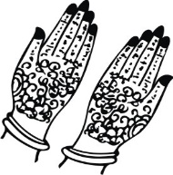
Kyle Shea Ring
and
Matthew James Pollard
On Wednesday, 30th May 2018
At 6pm
44 Parham Drive,
Ilford, Essex, IG2 6NB
IMAGES IN THE DOCUMENT CAN BE CHANGED (IF REQUIRED) TO THE IMAGES CHOSEN FROM OUR LIBRARY. PLEASE CLICK ON LINK BELOW TO BROWSE OUR LIBRARY OF IMAGES FOR MEHENDI CARD https://www.parekhcards.com/logos/Hindu-Invitation-Logos.asp

