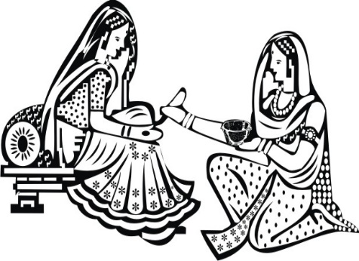
The family of the bride joyfully invites you to the
Mehendi Function
of
Avni and Abhishek
April 15th 2018 At 7 O’ clock in the evening
The Via Verde Country Club
1234 Via Verde Road, Covina, California
RSVP by 20 March to avi_abhi@gmail.com
IMAGES IN THE DOCUMENT CAN BE CHANGED (IF REQUIRED) TO THE IMAGES CHOSEN FROM OUR LIBRARY. PLEASE CLICK ON LINK BELOW TO BROWSE OUR LIBRARY OF IMAGES FOR MEHENDI CARD https://www.parekhcards.com/logos/Hindu-Invitation-Logos.asp

