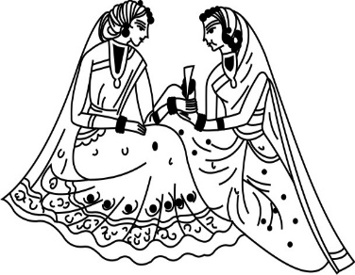
We would love for you
to join us for a
Mehendi Celebration
Thursday 2nd August 2018
seven to ten o’ clock in the evening
Hotel Biltmore
1260 Channel Drive
Santa Barbara, California
Kindly RSVP by July 20th to
foreverfiances@gmail.com
IMAGES IN THE DOCUMENT CAN BE CHANGED (IF REQUIRED) TO THE IMAGES CHOSEN FROM OUR LIBRARY. PLEASE CLICK ON LINK BELOW TO BROWSE OUR LIBRARY OF IMAGES FOR ENGAGEMENT CEREMONY https://www.parekhcards.com/logos/Hindu-Invitation-Logos.asp

