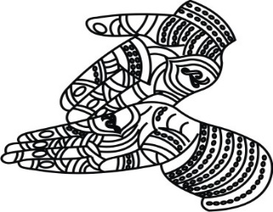
A Magical Mehndi Night
Esha, Ahana and Garry
Would like to invite you
For an evening of fun, music, dance & dinner
On the occasion of
Reva’s Mehndi Ceremony
At The Tejwani Residence
2586 Brightwater Place, Oviedo, FL 32765
123-456-7890
On Saturday 8th September 2018
From 6:00 pm – 10:00 pm
IMAGES IN THE DOCUMENT CAN BE CHANGED (IF REQUIRED) TO THE IMAGES CHOSEN FROM OUR LIBRARY. PLEASE CLICK ON LINK BELOW TO BROWSE OUR LIBRARY OF IMAGES FOR ENGAGEMENT CEREMONY https://www.parekhcards.com/logos/Hindu-Invitation-Logos.asp

