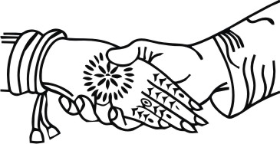
Ms Riya Handa
Requests the pleasure of
___________________________________________
on the auspicious occasion of the marriage of her daughter
Shanaya Adassa Handa
to
William James Leslie Thoms
Son of the Reverend Michael & Mrs Caroline Thoms
On Saturday 1st September 2018
At The Catholic Church of the Holy Family,
Reigate and Robert Denholm House, Nutfield
Dress code: Lounge Suits
Colourful Dresses
Traditional Dress
R.S.V.P. by 1st May 2018
Bela: 07887 484524
jayaandwill@gmail.com
LOGOS/SYMBOLS IN THE DOCUMENT CAN BE CHANGED (IF REQUIRED) TO THE LOGOS/SYMBOLS CHOSEN FROM OUR LIBRARY.
CLICK HERE TO BROWSE OUR LIBRARY OF LOGOS/SYMBOLS.

Together with their parents,
Shanaya & William
Request the pleasure of
______________________________________________
to the wedding reception following their marriage
On Saturday 1st September 2018
From 8pm onwards
At Robert Denholm House
Bletchingley Rd, Nutfield RH1 4HW
R.S.V.P. by 1st May 2018
Bela: 07887 484524
jayaandwill@gmail.com
Dress code:
Gowns or Colourful Dress Suit
Formal or Black Tie
LOGOS/SYMBOLS IN THE DOCUMENT CAN BE CHANGED (IF REQUIRED) TO THE LOGOS/SYMBOLS CHOSEN FROM OUR LIBRARY.
CLICK HERE TO BROWSE OUR LIBRARY OF LOGOS/SYMBOLS.

