Naina and Shashi
Wedding
Cordially invite
__________________________________________________________
to grace the auspicious wedding ceremony
of their daughter
Sanchi
to
Shai
Son of Shilaben and Pyushbhai
On Friday 1st September 2017
Arrival of Baraat: 8.00am
Breakfast: 8.30am
Guests are requested to be seated
by 9.45am
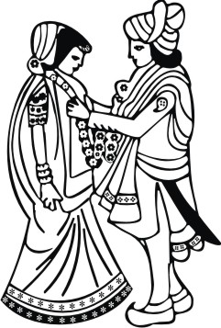
Venue
Heston Hyde Hotel,
North Hyde Lane,
Hounslow, Middlesex, TW5 0EP
LOGOS/SYMBOLS IN THE DOCUMENT CAN BE CHANGED (IF REQUIRED) TO THE LOGOS/SYMBOLS CHOSEN FROM OUR LIBRARY. CLICK HERE TO BROWSE OUR LIBRARY OF LOGOS/SYMBOLS.

A very big Thank You
Reception
For sharing and being an important part of our lives
We would simply love to share the first day of being
Mr. and Mrs. Shah with
_______________________________________________________
On Friday 1st September 2017
Cocktail hour: 6.00pm - 7.00pm
Followed by Reception & Dinner
Departure of Barrat - 11.00 pm
Dress code: Black tie and Indian attire
Venue
Heston Hyde Hotel,
North Hyde Lane,
Hounslow, Middlesex, TW5 0EP
LOGOS/SYMBOLS IN THE DOCUMENT CAN BE CHANGED (IF REQUIRED) TO THE LOGOS/SYMBOLS CHOSEN FROM OUR LIBRARY. CLICK HERE TO BROWSE OUR LIBRARY OF LOGOS/SYMBOLS.

