Anand Karaj
Mr. Shashi Lalvani and Mrs. Sharmila Lalvani
&
Mr. Sulaiman Sheriff and Mrs. Tilat Rizvi
request the honor of your presence at the
marriage ceremony uniting their children
Maroui Lalvani
and
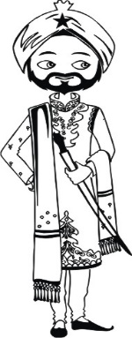
Rizvan Sheriff
Saturday, January 13, 2018
Jaan Prasthan ............. 10:30 am
Milni .......................... 11:00 am
Anand Karaj ............... 11:30 pm
Langar ....................... 12:30 pm
Guru Nanak Society of Greater Cincinnati
4394 Tylersville Rd, West Chester Township, OH 45011
LOGOS/SYMBOLS IN THE DOCUMENT CAN BE CHANGED (IF REQUIRED) TO THE LOGOS/SYMBOLS CHOSEN FROM OUR LIBRARY.
CLICK HERE TO BROWSE OUR LIBRARY OF LOGOS/SYMBOLS.

Reception
Mr. Shashi Lalvani and Mrs. Latika Lalvani
&
Mr. Sulaiman Sheriff and Mrs. Tilat Rizvi
kindly request the honor of your presence
to celebrate the newlywed couple
Maroui Lalvani
and
Rizvan Sheriff
Saturday, January 13, 2018
Cocktail Hour .............. 6:30 pm
Seated Dinner ............. 7:30 pm
Cincinnati Music Hall
1241 Elm St, Cincinnati, OH 45202
Please refer to www.theknot.com/us/maroui-and-ahmer
for hotel accommodations and other details
LOGOS/SYMBOLS IN THE DOCUMENT CAN BE CHANGED (IF REQUIRED) TO THE LOGOS/SYMBOLS CHOSEN FROM OUR LIBRARY.
CLICK HERE TO BROWSE OUR LIBRARY OF LOGOS/SYMBOLS.

