|| Shree Ganeshaya Namah ||
Mr. and Mrs. Yogesh and Bhavna Desai
request the honor of your presence at the
marriage of their son
Vishal al Neha
Daughter of Mr. Jube Daniel and Mrs. Elsy Jube
on Saturday, the Fourth of August Two Thousand Eighteen
Baraat at eight-thirty in the morning
Wedding Ceremony at ten o’clock in the morning
Hanover Marriott
1401 NJ-10, Whippany, New Jersey 07981
Lunch to follow.

LOGOS/SYMBOLS IN THE DOCUMENT CAN BE CHANGED (IF REQUIRED) TO THE LOGOS/SYMBOLS CHOSEN FROM OUR LIBRARY.
CLICK HERE TO BROWSE OUR LIBRARY OF LOGOS/SYMBOLS.

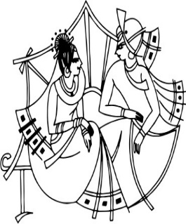
Mr. and Mrs. Yogesh and Bhavna Desai
and
Mr. Jube Daniel and Mrs. Elsy Jube
Request the pleasure of your company at the
~Wedding Reception~
in honor of the newlyweds
Vishal and Neha
on Sunday the Fifth of August Two Thousand Eighteen
Cocktail hour will begin at six o’clock in the evening
Dinner will begin at seven o’clock in the evening
Hanover Marriott
1401 NJ-10, Whippany, New Jersey 07981
No boxed gifts please.
LOGOS/SYMBOLS IN THE DOCUMENT CAN BE CHANGED (IF REQUIRED) TO THE LOGOS/SYMBOLS CHOSEN FROM OUR LIBRARY.
CLICK HERE TO BROWSE OUR LIBRARY OF LOGOS/SYMBOLS.

