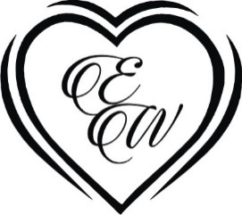

Together with their parents
Elle Parker
and
William Bradford
Invite you to their wedding
Monday October 1st, 2018
At Five O’ Clock
Sundstone Winery
125 N Refugio Road, Santa Ynez, California

Dinner & Dancing to follow
LOGOS/SYMBOLS IN THE DOCUMENT CAN BE CHANGED (IF REQUIRED) TO THE LOGOS/SYMBOLS CHOSEN FROM OUR LIBRARY. CLICK HERE TO BROWSE OUR LIBRARY OF LOGOS/SYMBOLS.

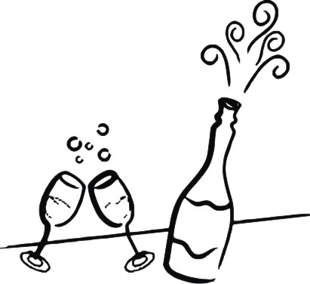

Together with their parents
Elle Parker
and
William Bradford
Cordially invite you to their Reception

Tuesday October 2nd, 2018
At Seven O’ Clock

Sundstone Winery
125 N Refugio Road, Santa Ynez, California

Cocktails & Dinner to follow

LOGOS/SYMBOLS IN THE DOCUMENT CAN BE CHANGED (IF REQUIRED) TO THE LOGOS/SYMBOLS CHOSEN FROM OUR LIBRARY. CLICK HERE TO BROWSE OUR LIBRARY OF LOGOS/SYMBOLS.

