Mr Gurdev Singh & Mrs Naginder Kaur Basi
Request the pleasure of your company to grace
the auspicious occasion of the marriage
of their beloved daughter
Manpreet Kaur
Granddaughter of
Mr Paramit Singh & Mrs Surjit Kaur Basi
and
Mr Gurmeet Singh & Mrs Parmeet Kaur Atwal
with
Gurminder Singh
Son of
Mr Paramdeep Singh Patara & Mrs Simmi Kaur Patara
With compliments from:
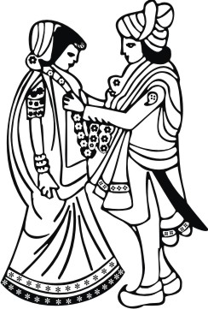
Dhaliwal Family
Randhawa Family
Gohal Family
Sandhu Family
No gifts please
LOGOS/SYMBOLS IN THE DOCUMENT CAN BE CHANGED (IF REQUIRED) TO THE LOGOS/SYMBOLS CHOSEN FROM OUR LIBRARY. CLICK HERE TO BROWSE OUR LIBRARY OF LOGOS/SYMBOLS.

Wedding Programme
Saturday 28th April 2018
at
Guru Nanak Sikh Gurdwara
Well Lane, Wednesfield, Wolverhampton,
West Midlands, WV11 1XT
Reception of Barat & Milni ................... 9:30 am
Tea .......................................................... 10:15 am
Anand Karaj .......................................... 10:40 am
Wedding Reception
at
Royale Banqueting Suite
Pountney Street, Wolverhampton
West Midlands, WV2 4HX
Reception .............................. 12:00 pm - 6:00 pm
Departure of Doli .................................... 6:35 pm
LOGOS/SYMBOLS IN THE DOCUMENT CAN BE CHANGED (IF REQUIRED) TO THE LOGOS/SYMBOLS CHOSEN FROM OUR LIBRARY. CLICK HERE TO BROWSE OUR LIBRARY OF LOGOS/SYMBOLS.

