Mr. Kulraj Singh & Mrs. Sukhvinder Kaur Sodhi
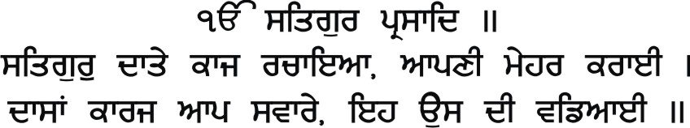
request the honour of your presence at the marriage ceremony of their beloved daughter
Ramanpreet Kaur Sodhi
(Grandaughter of Late Mr. Pragat Singh & Late Mrs. Jagjit Kaur Sodhi,
Mr. Gulzar Singh & Mrs. Harbans Kaur Batra)
Sukhjeet Singh Chopra
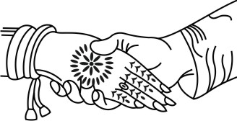
(son of Mr. Kumar Singh & Mrs. Krishna Chopra)
to be celebrated
With Best Wishes From:
Sodhi Family, Batra Family
All Relatives & Friends
Please RSVP by
April 18th, 2018
ramanwedsukh@gmail.com
on Saturday May 5, 2018

LOGOS/SYMBOLS IN THE DOCUMENT CAN BE CHANGED (IF REQUIRED) TO THE LOGOS/SYMBOLS CHOSEN FROM OUR LIBRARY.
CLICK HERE TO BROWSE OUR LIBRARY OF LOGOS/SYMBOLS.

“Ek Jot Doye Murti”
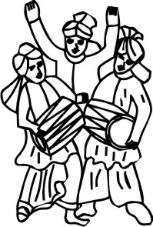
“They are not said to be husband and wife who merely sit together.
Rather they alone are called husband and wife, who have one soul in two bodies.”
- Guru Amar Das
~: Programme :~
No Boxed Gifts Please
LOGOS/SYMBOLS IN THE DOCUMENT CAN BE CHANGED (IF REQUIRED) TO THE LOGOS/SYMBOLS CHOSEN FROM OUR LIBRARY.
CLICK HERE TO BROWSE OUR LIBRARY OF LOGOS/SYMBOLS.

Wedding Ceremony
Reception of Barat - 9:00am
Milni - 9:30am
Tea & Refreshments - 10:00am
Anand Karaj - 10:30am
Guru Ka Langar - 12:30pm
To be held at:
Rexdale Gurdwara Sahib
9 Carrier Drive, Toronto,
Ontario, M9V 4B2
Reception
Cocktail Hour - 6:30pm
Dinner - 10:00pm
To be held at:
Verdi Banquet Hall
3550 Derry Road East, Mississauga,
Ontario, L4T 3V7

