**Mr. Inderjit S. Gill and Mrs. Baljit K. Gill**

request the honor of your presence on the auspicious

occasion of the marriage of their beloved daughter

**Naveender**

With

**Inderpal**

Son of Mr. Bhagwant S. Sukh and Mrs. Surinder K. Sukh

On Sunday, May 6, 2018

at Gurdwara Sahib, El Sobrante, CA

**Program**

Milni and Tea - Reception of Baraat 10:00 a.m.

Anand Karaj - Wedding Ceremony 11:00 a.m.

Langar (Lunch) 12:00 noon

Doli 1:30 p.m.

**A**

**n**

**a**

**n**

**d**

**K**

**a**

**r**

**a**

**j**

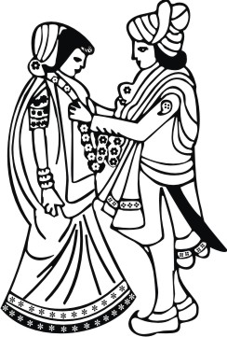

**LOGOS/SYMBOLS IN THE DOCUMENT CAN BE CHANGED (IF REQUIRED) TO THE LOGOS/SYMBOLS CHOSEN FROM OUR LIBRARY.**[**CLICK HERE**](https://drive.google.com/drive/folders/1mexxxOBpusGDXVfdDxVjYFbjZXUkjlB6) **TO BROWSE OUR LIBRARY OF LOGOS/SYMBOLS.**

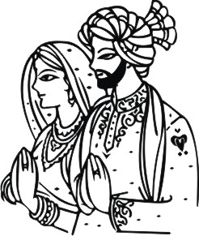

**R**

**e**

**c**

**e**

**p**

**t**

**i**

**o**

**n**

**Mr. Inderjit S. Gill and Mrs. Baljit K. Gill**

request the pleasure of your company at the

wedding reception of their beloved daughter

**Naveender**

And

**Inderpal**

On Monday, May 7, 2018

at Paradise Banquet Hall

4100 Peralta Blvd., Fremont, CA 94536

**Program**

Cocktail Hour 6:00 p.m.

Reception 7:00 p.m.

**LOGOS/SYMBOLS IN THE DOCUMENT CAN BE CHANGED (IF REQUIRED) TO THE LOGOS/SYMBOLS CHOSEN FROM OUR LIBRARY.**[**CLICK HERE**](https://drive.google.com/drive/folders/1mexxxOBpusGDXVfdDxVjYFbjZXUkjlB6) **TO BROWSE OUR LIBRARY OF LOGOS/SYMBOLS.**