Mrs. Narinder Kaur & Mr. Balvant Singh
request the pleasure of your company on the
auspicious occasion of the marriage
of their daughter
Simran Kaur
to
Harpreet Singh
son of Mrs. Ashu Kaur & Mr. Jasvir Singh
on Saturday 27th of January, 2018
at Sri Guru Nanak Sikh Temple
2269 Bogue Road, Yuba City, CA 95993
~Program~
Arrival of Barat & Milni ................. 9:30 a.m.
Wedding Ceremony ............................. 11:00 a.m.
Lunch .................................................... 1:00 p.m.
Doli from Residence ........................... 5:00 p.m.
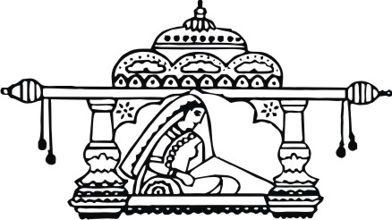
R.S.V.P. :
Mr. Balvant Singh
Tel: (530) 254-2265
Best Wishes From:
Singh Family
& All Relatives
LOGOS/SYMBOLS IN THE DOCUMENT CAN BE CHANGED (IF REQUIRED) TO THE LOGOS/SYMBOLS CHOSEN FROM OUR LIBRARY. CLICK HERE TO BROWSE OUR LIBRARY OF LOGOS/SYMBOLS.

~Wedding Reception~
Mrs. Narinder Kaur & Mr. Balvant Singh
request the honor of your presence for a night
of celebration at the reception of
Simran Kaur
and
Harpreet Singh
On Sunday 28th of January, 2018
6:00 p.m.
at
White Lotus Banquet Hall
6105 Sunrise Vista Drive
Citrus Hieghts, CA 95610
LOGOS/SYMBOLS IN THE DOCUMENT CAN BE CHANGED (IF REQUIRED) TO THE LOGOS/SYMBOLS CHOSEN FROM OUR LIBRARY. CLICK HERE TO BROWSE OUR LIBRARY OF LOGOS/SYMBOLS.

