Together with the blessing of their parents
Harmeet Kaur
D/O Kamlesh & Lakhvinder Kaur Sandhu
&
Surinder Singh
S/O Sukhvinder Singh & Manjeet Kaur
Request the honour of your presence on the
auspicious occasion of their marriage on
Friday 27th April 2018
At
Sri Guru Singh Sabha
Wexham Court, Sheehy Way, Slough, SL2 5SS
Following Programme to start at 9am
Arrival of Baraat
Milni
Tea
Anand Karaj - Wedding Ceremony
Doli from residence
LOGOS/SYMBOLS IN THE DOCUMENT CAN BE CHANGED (IF REQUIRED) TO THE LOGOS/SYMBOLS CHOSEN FROM OUR LIBRARY. CLICK HERE TO BROWSE OUR LIBRARY OF LOGOS/SYMBOLS.

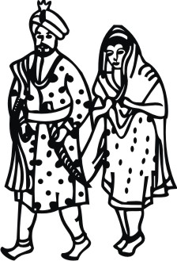
Please RSVP by
14th March 2018
Together with their loved ones
Harmeet
&
Surinder
Request the pleasure of your company for a
night of celebration at the reception
of their wedding on
Saturday 28th April 2018
At
Baylis House
Stoke Poges Lane
Slough
SL1 3PB
From 7.30pm till late
LOGOS/SYMBOLS IN THE DOCUMENT CAN BE CHANGED (IF REQUIRED) TO THE LOGOS/SYMBOLS CHOSEN FROM OUR LIBRARY. CLICK HERE TO BROWSE OUR LIBRARY OF LOGOS/SYMBOLS.

Please RSVP by
14th March 2018
IMAGES IN THE DOCUMENT CAN BE CHANGED (IF REQUIRED) TO THE IMAGES CHOSEN FROM OUR LIBRARY. PLEASE CLICK ON LINK BELOW TO BROWSE OUR LIBRARY OF IMAGES FOR SIKH WEDDINGhttps://www.parekhcards.com/logos/Sikh-Invitation-Logos.asp

