Template: CNV-Regal Meadow
(1st Slide – Mandatory)
Bride & Grooms’ Name’s (Maximum 2 Characters)
Mitesh & Preeti
Invitation Line-1 (Maximum 40 Characters)
#MitkiPreet
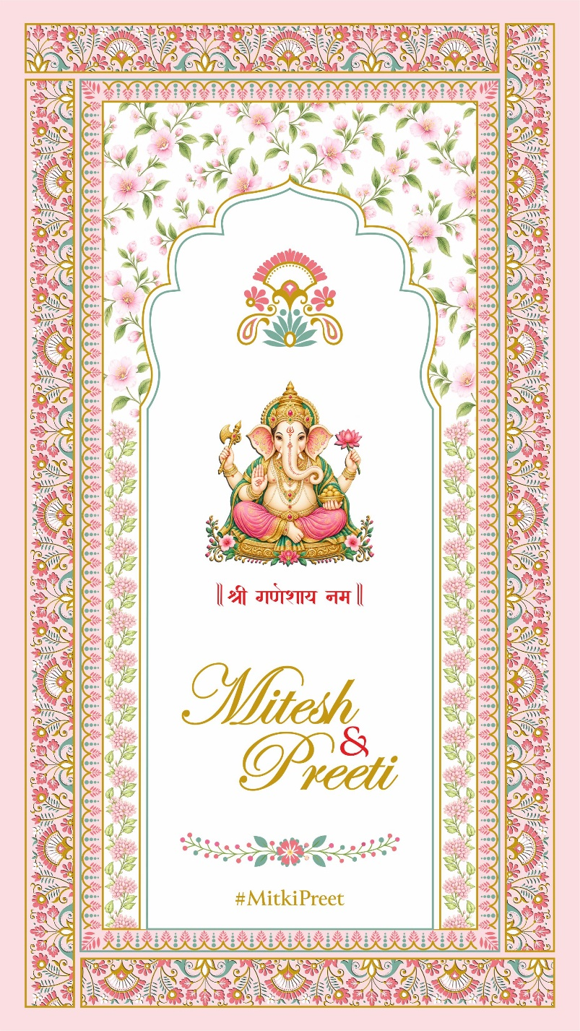
Important Information:
- Keep the text minimal for the best video e-invite results.
- Overwrite and enter wording in each cell within the specified character limits. This ensures a larger and more readable font size.
- If extra wording is needed beyond the limit, share it via own MS Word Doc or email.
- Couple’s Monogram can be replaced with Religious Logo at No Cost!

Template: CNV-Regal Meadow
(2nd Slide)
Grand Parents Name (Maximum 100 Characters)
With the Blessings of Grandparents Late Mrs. Sheetal Shah & Mr. Ramesh Shah
Invitation Line-1 (Maximum 150 Characters)
Smt. Neeta & Shri Anup Shah Request the honour of your presence at the Wedding Celebration of their son
Groom/Bride Name (Maximum 25 Characters)
Mitesh
Invitation Line-1 (Maximum 10 Characters)
with
Groom/Bride Name (Maximum 25 Characters)
Preeti
Groom/Bride Parents Name (Maximum 75 Characters)
Daughter of Smt. Chandrika and Shri Jiten Vora
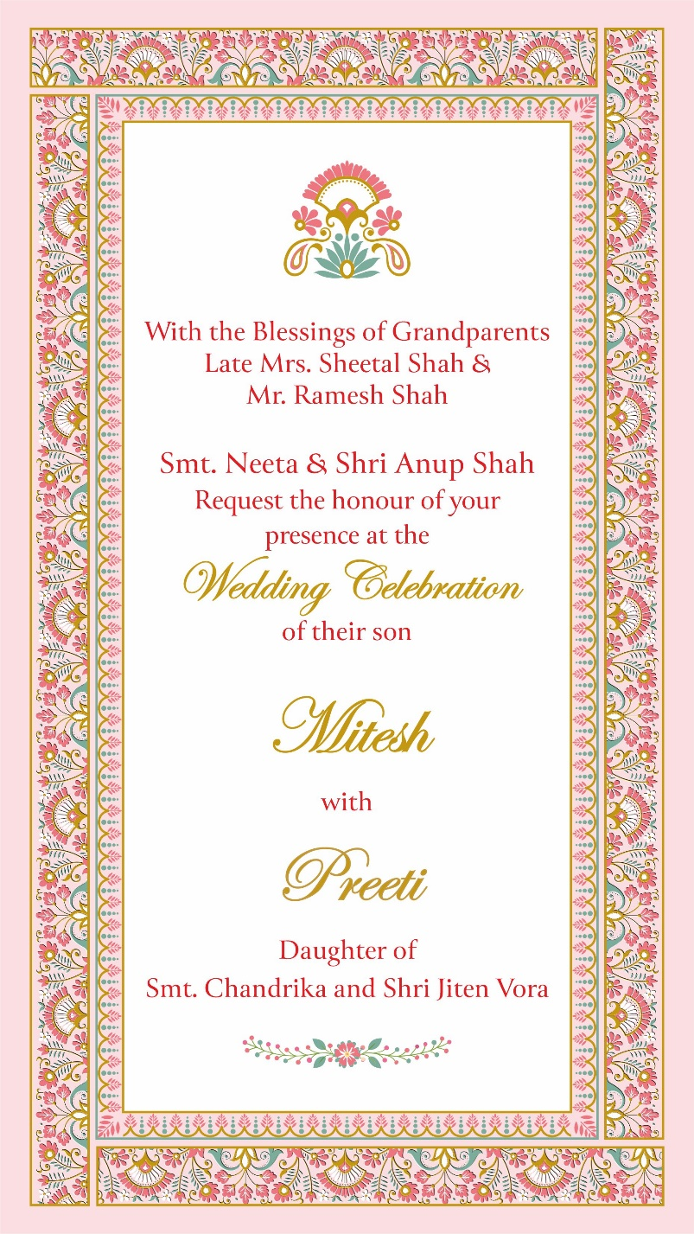

Template: CNV-Regal Meadow
(3rd Slide)
Event Title (Maximum 20 Characters)
Mehendi The Heena Soiree
Invitation Line 1 (Maximum 150 Characters)
Painted in henna, wrapped in joy, Let the celebrations begin!
Date (Maximum 40 Characters)
Wednesday 21st April 2027
Time (Maximum 50 Characters)
at 6:30pm onwards
Venue Name & Address (Maximum 100 Characters)
Hotel Sea Princess, Juhu Tara Rd, Juhu, Mumbai - 49
Invitation Line 2 (Maximum 100 Characters)
Attire: Vibrant Indian
Invitation Line 3 (Maximum 150 Characters)
With Love: Kartik, Harish & Geeta
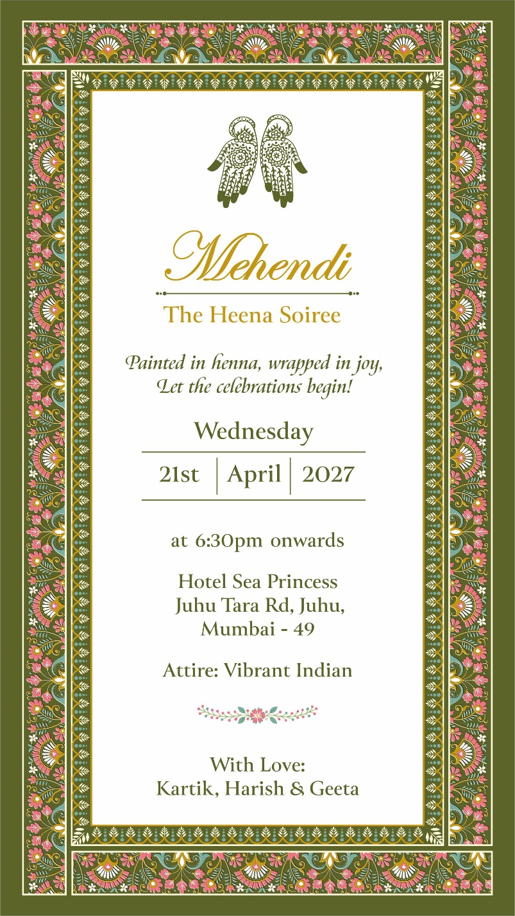

Template: CNV-Regal Meadow
(4th Slide)
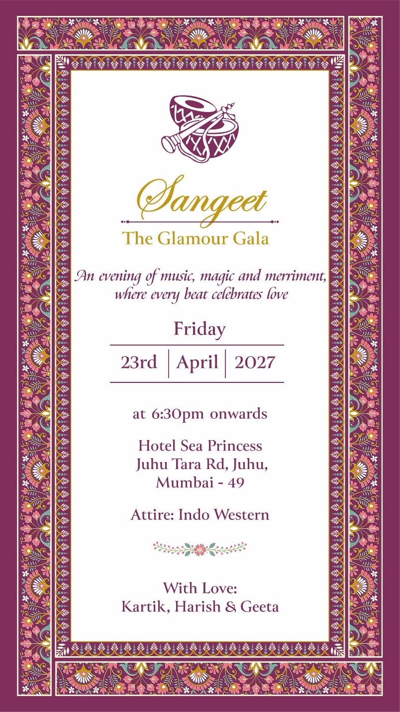

Event Title (Maximum 20 Characters)
Sangeet The Glamour Gala
Invitation Line 1 (Maximum 150 Characters)
An evening of music, magic and merriment, where every beat celebrates love
Date (Maximum 40 Characters)
Wednesday 21st April 2027
Time (Maximum 50 Characters)
at 6:30pm onwards
Venue Name & Address (Maximum 100 Characters)
Hotel Sea Princess, Juhu Tara Rd, Juhu, Mumbai - 49
Invitation Line 2 (Maximum 100 Characters)
Attire: Indo Western
Invitation Line 3 (Maximum 150 Characters)
With Love: Kartik, Harish & Geeta

Template: CNV-Regal Meadow
(5th Slide)
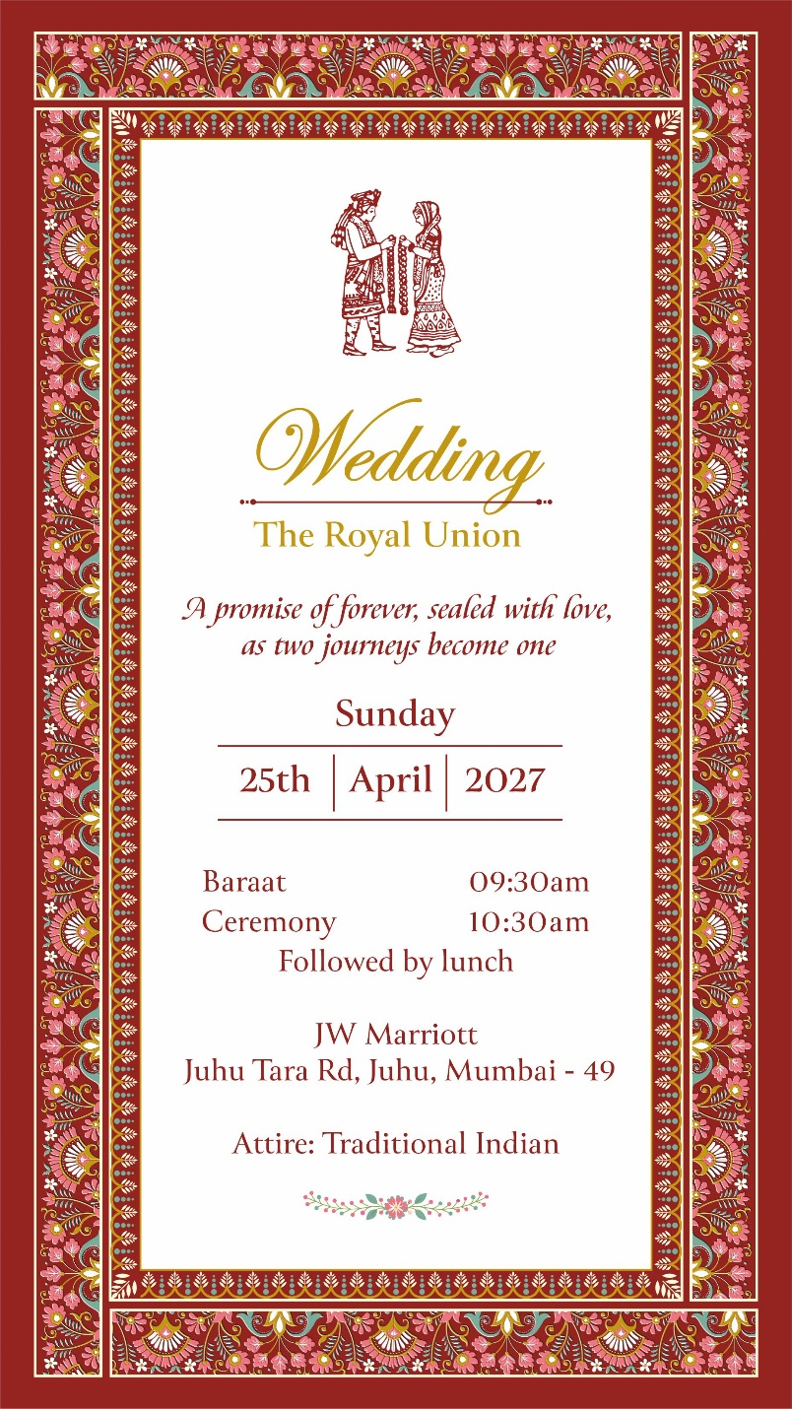

Event Title (Maximum 20 Characters)
Wedding The Royal Union
Invitation Line 1 (Maximum 150 Characters)
A promise of forever, sealed with love, as two journeys become one
Date (Maximum 40 Characters)
Sunday 25th April 2027
Time (Maximum 100 Characters)
Baraat 09:30am Ceremony 10:30am Follwed by lunch
Venue Name & Address (Maximum 100 Characters)
JW Marriott, Juhu Tara Rd, Juhu, Mumbai - 49
Invitation Line 2 (Maximum 50 Characters)
Attire: Traditional Indian

Template: CNV-Regal Meadow
(6th Slide)
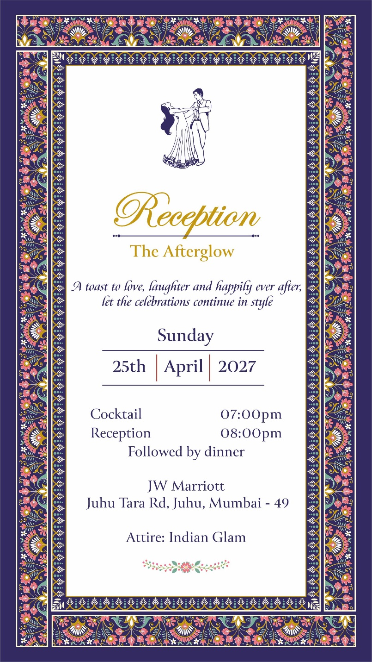

Event Title (Maximum 20 Characters)
Reception The Afterglow
Invitation Line 1 (Maximum 150 Characters)
A toast to love, laughter and happily ever after, let the celebrations continue in style
Date (Maximum 40 Characters)
Sunday 25th April 2027
Time (Maximum 100 Characters)
Cocktail 07:00pm Reception 08:00pm followed by dinner
Venue Name & Address (Maximum 100 Characters)
JW Marriott, Juhu Tara Rd, Juhu, Mumbai - 49
Invitation Line 2 (Maximum 50 Characters)
Attire: Indian Glam

Template: CNV-Regal Meadow
(7th Slide)
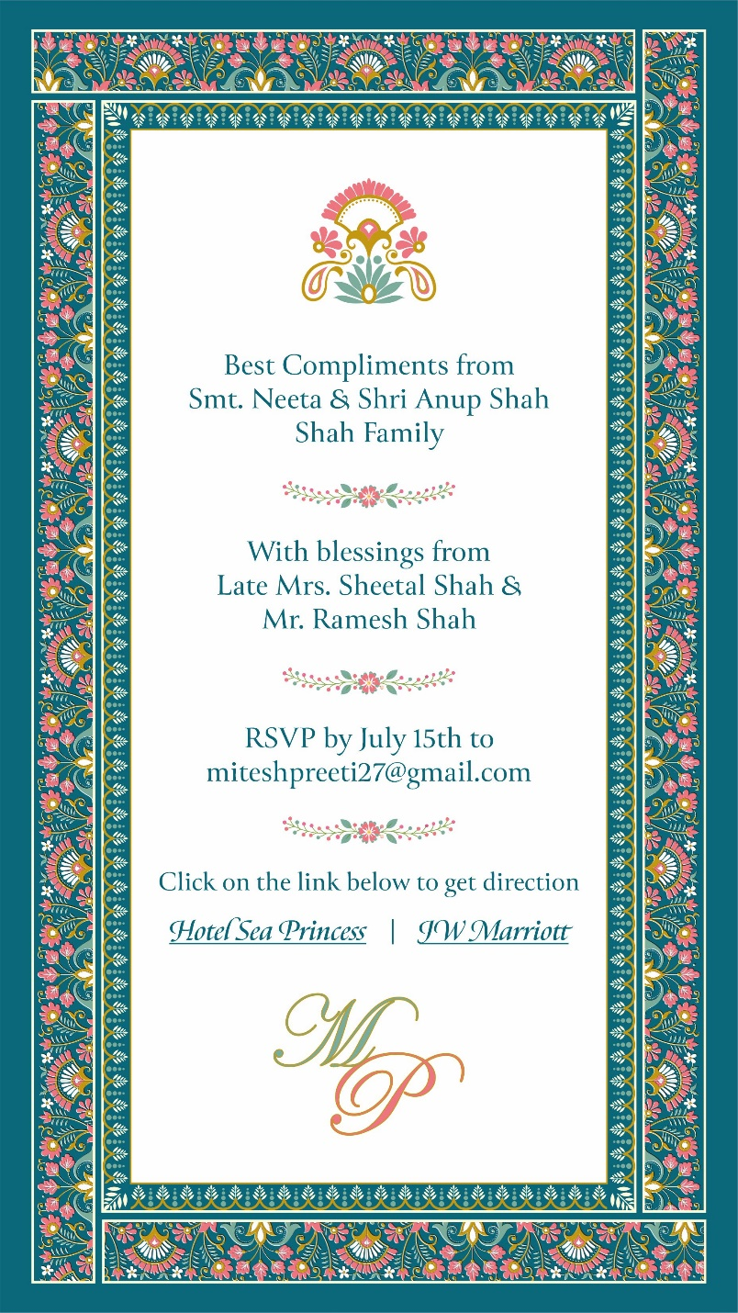

Invitation Line 1 (Maximum 50 Characters)
Best Compliments from
Compliments Name (Maximum 150 Characters)
Smt. Neeta & Shri Anup Shah Shah Family
Invitation Line 2 (Maximum 50 Characters)
With blessings from
Blessing Name (Maximum 150 Characters)
Late Mrs. Sheetal Shah & Mr. Ramesh Shah
Invitation Line 3 (Maximum 150 Characters)
RSVP by July 15th to miteshpreeti27@gmail.com
Invitation Line 4 (Maximum 100 Characters)
Click on the link below to get direction
Hotel Sea Princess | JW Marriott
Invitation Line 5 (Maximum 2 Characters)
MP

