**DSD-Happy-Couple**

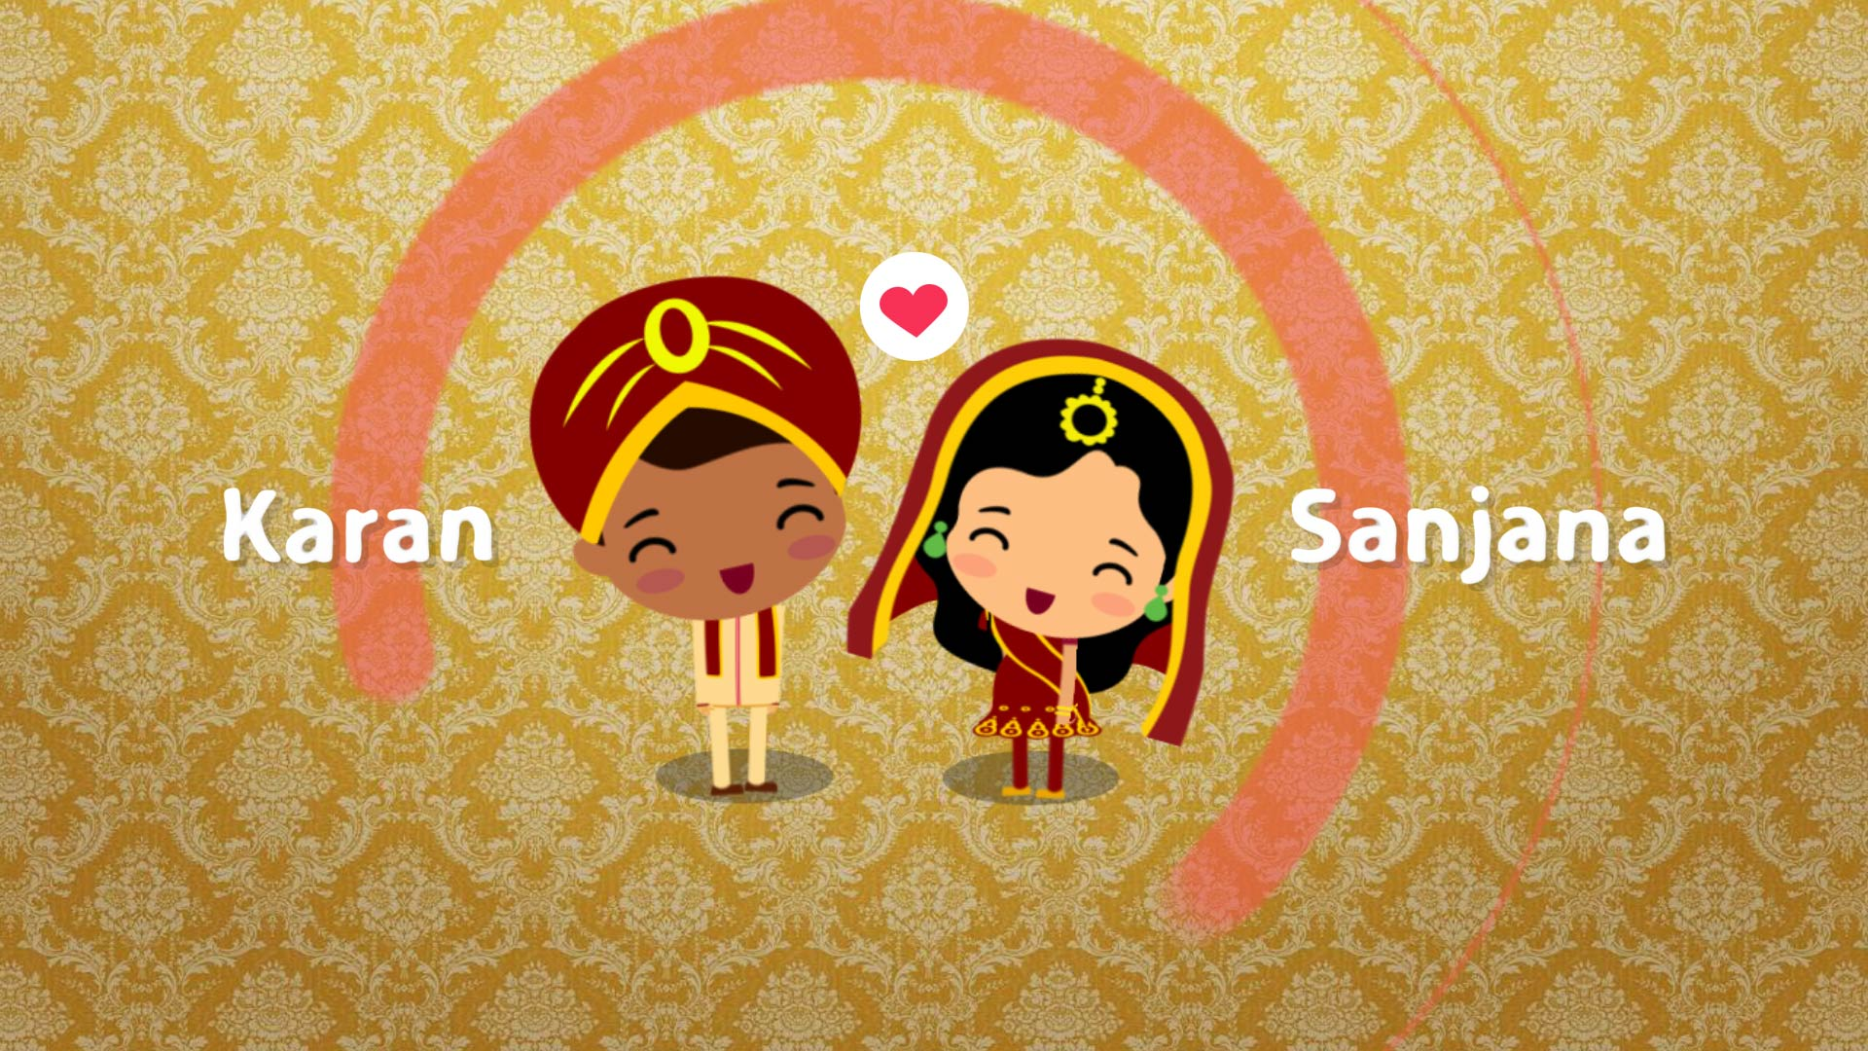

**SLIDE-1**

___________________________________

___________________________________

**DSD-Happy-Couple**



**SLIDE-2**

___________________________________

___________________________________

**DSD-Happy-Couple**



**SLIDE-3**

___________________________________

___________________________________

___________________________________

___________________________________

___________________________________

___________________________________

**DSD-Happy-Couple**



**SLIDE-4**

___________________________________

___________________________________

___________________________________

___________________________________

___________________________________

___________________________________

**DSD-Happy-Couple**



**SLIDE-5**

___________________________________

___________________________________

___________________________________

___________________________________