**DSD-Love-Birds**

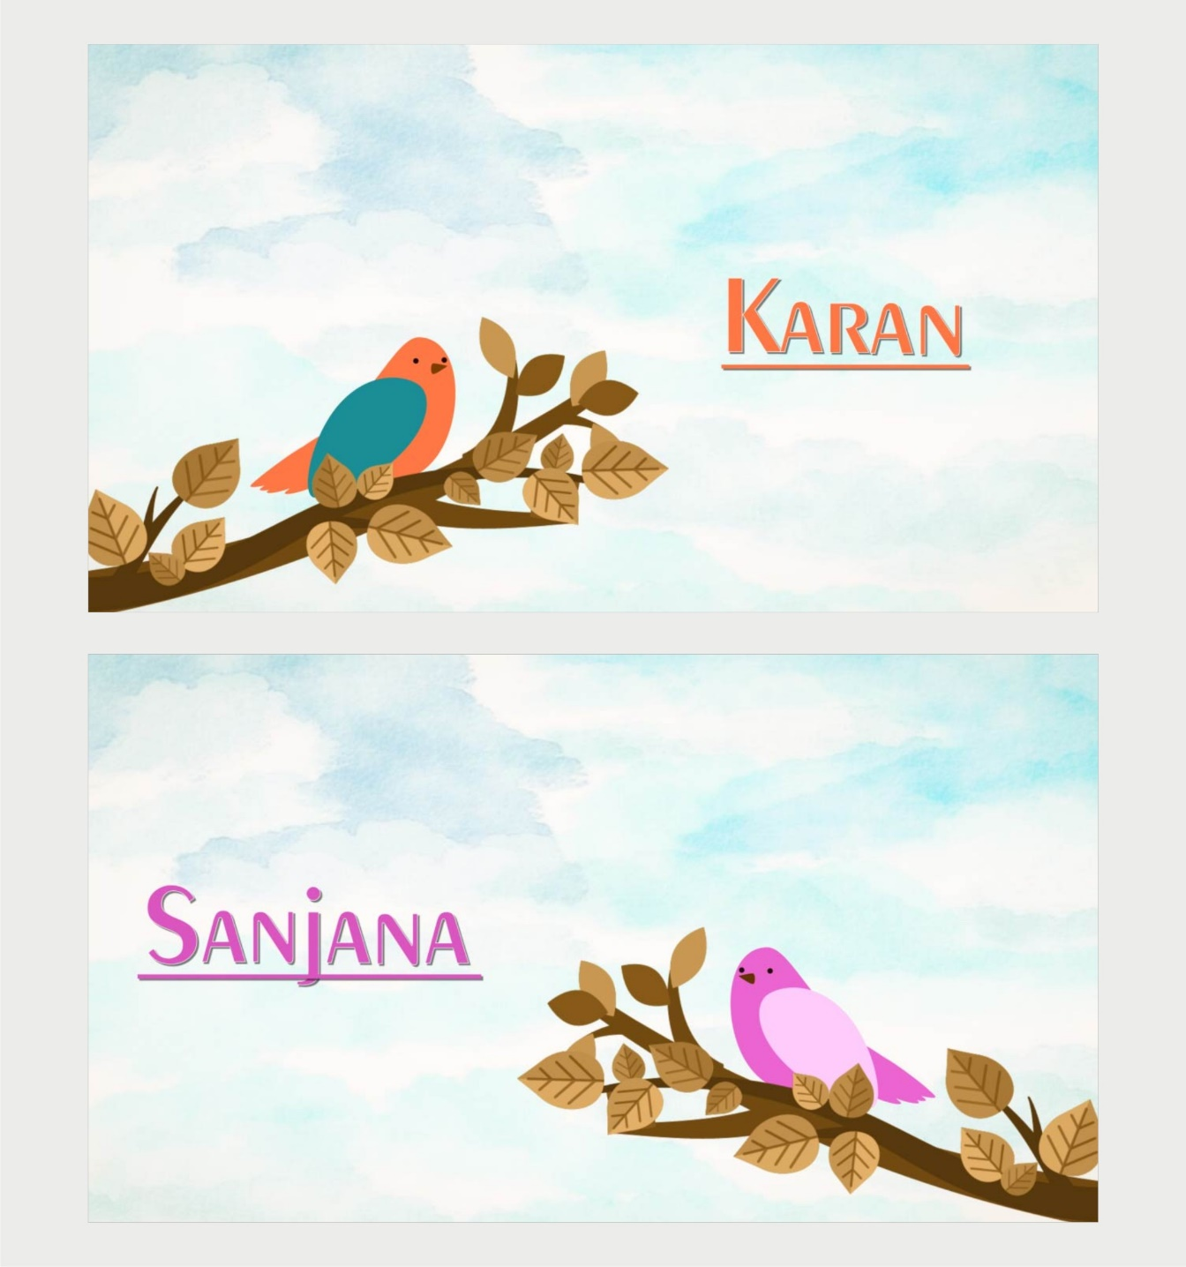

**SLIDE-1 & 2**

___________________________________

___________________________________

**DSD-Love-Birds**

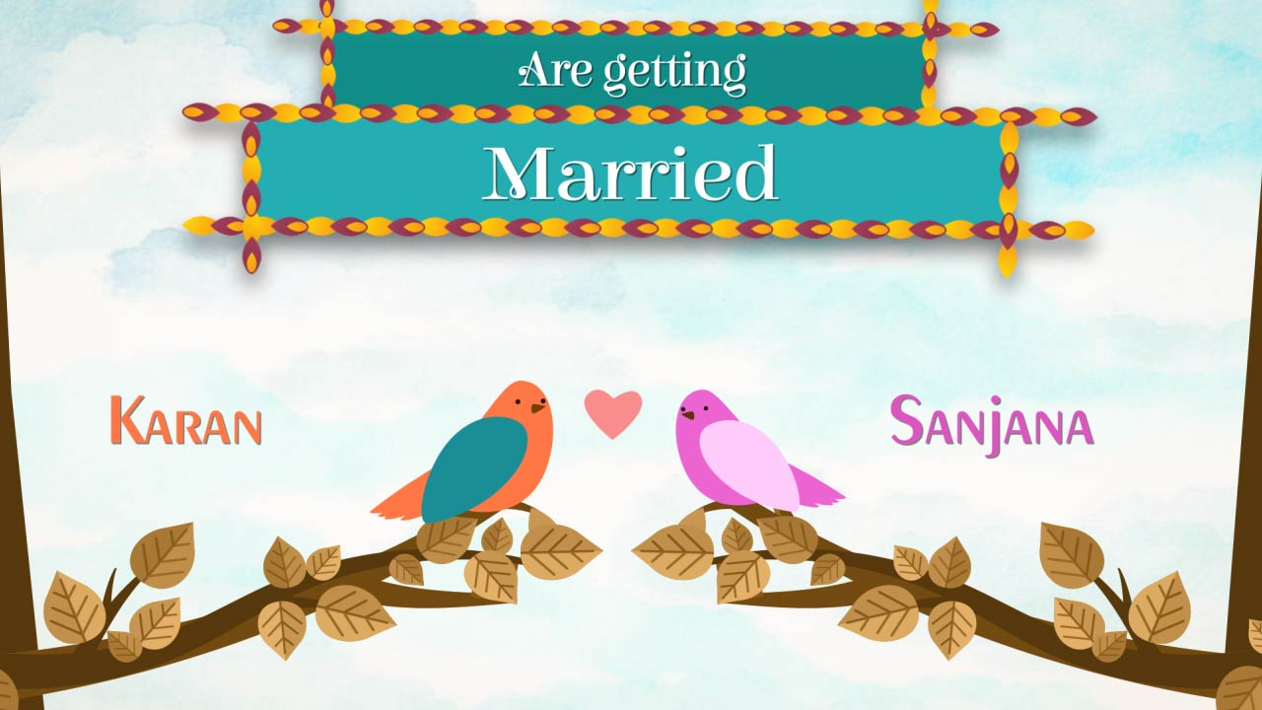

**SLIDE-3**

___________________________________

___________________________________

___________________________________

**DSD-Love-Birds**

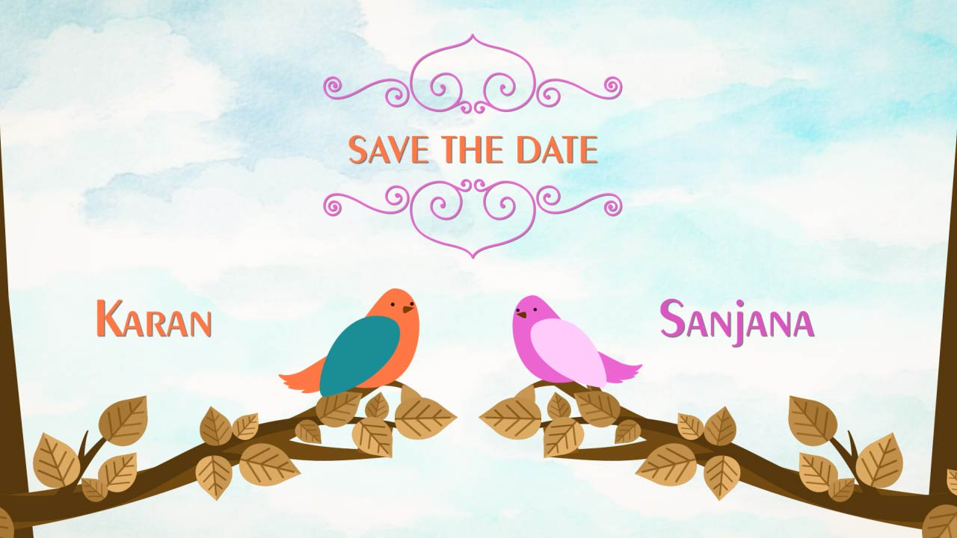

**SLIDE-4**

___________________________________

**DSD-Love-Birds**



**SLIDE-5**

___________________________________

___________________________________

___________________________________

___________________________________

___________________________________

**DSD-Love-Birds**



**SLIDE-6**

___________________________________

___________________________________

___________________________________

___________________________________

___________________________________

**DSD-Love-Birds**



**SLIDE-7**

___________________________________

___________________________________