**DTC-Border Frame Invitation English**



**SLIDE-1**

___________________________________

___________________________________

**DTC-Border Frame Invitation English**

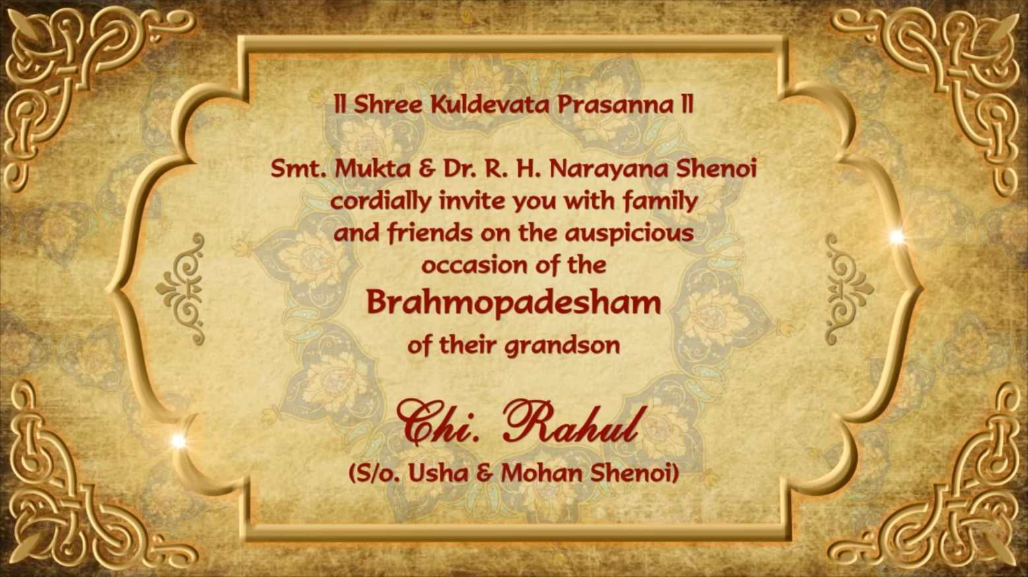

**SLIDE-2**

___________________________________

___________________________________

___________________________________

___________________________________

___________________________________

___________________________________

**DTC-Border Frame Invitation English**

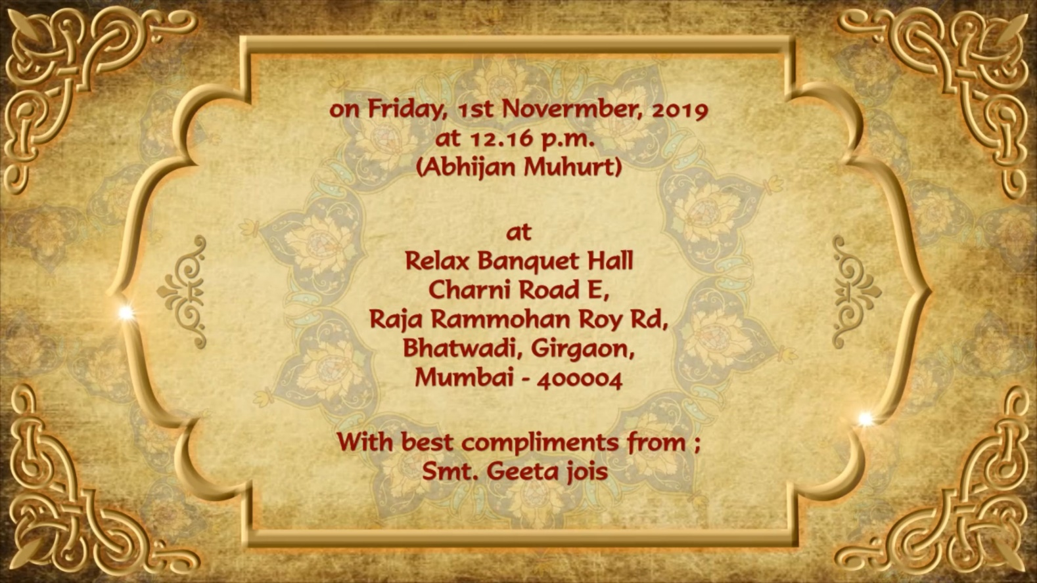

**SLIDE-3**

___________________________________

___________________________________

___________________________________

___________________________________

___________________________________

___________________________________