DTC-Brahmopadesham Ceremony

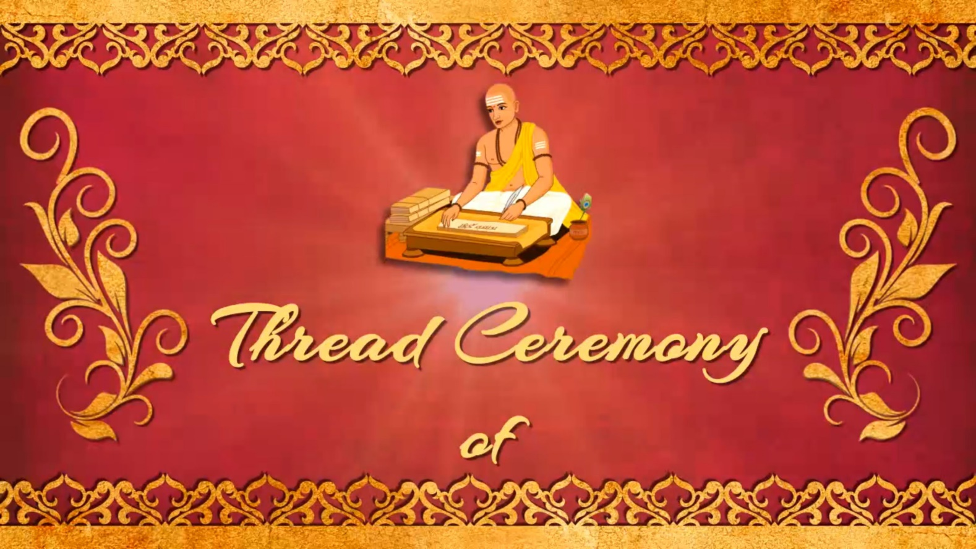

SLIDE-1
___________________________________
___________________________________
___________________________________
___________________________________
DTC-Brahmopadesham Ceremony

SLIDE-2
Attach High Resolution Image with email
___________________________________

DTC-Brahmopadesham Ceremony

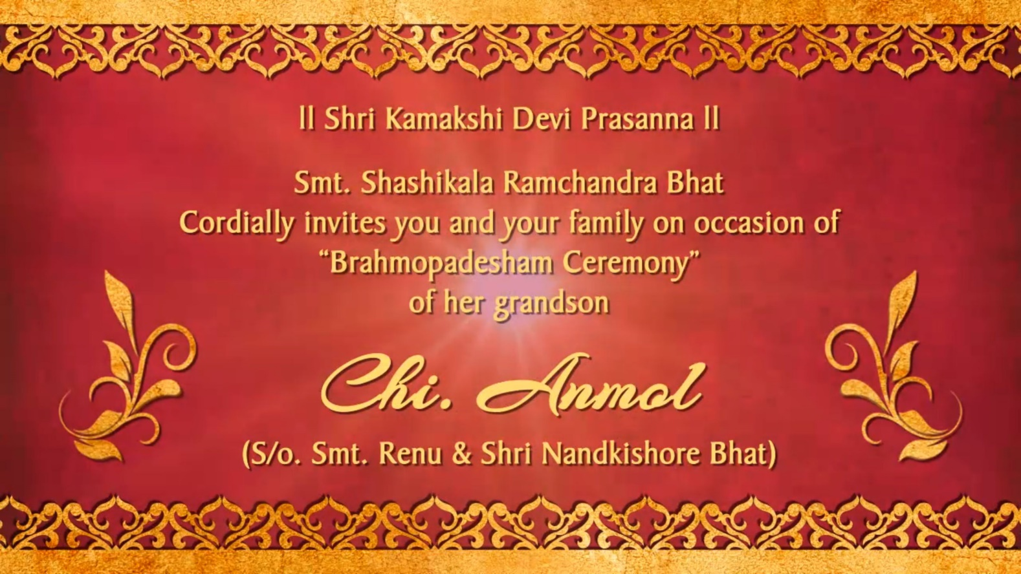

SLIDE-3
___________________________________
___________________________________
___________________________________
___________________________________
___________________________________
___________________________________

DTC-Brahmopadesham Ceremony

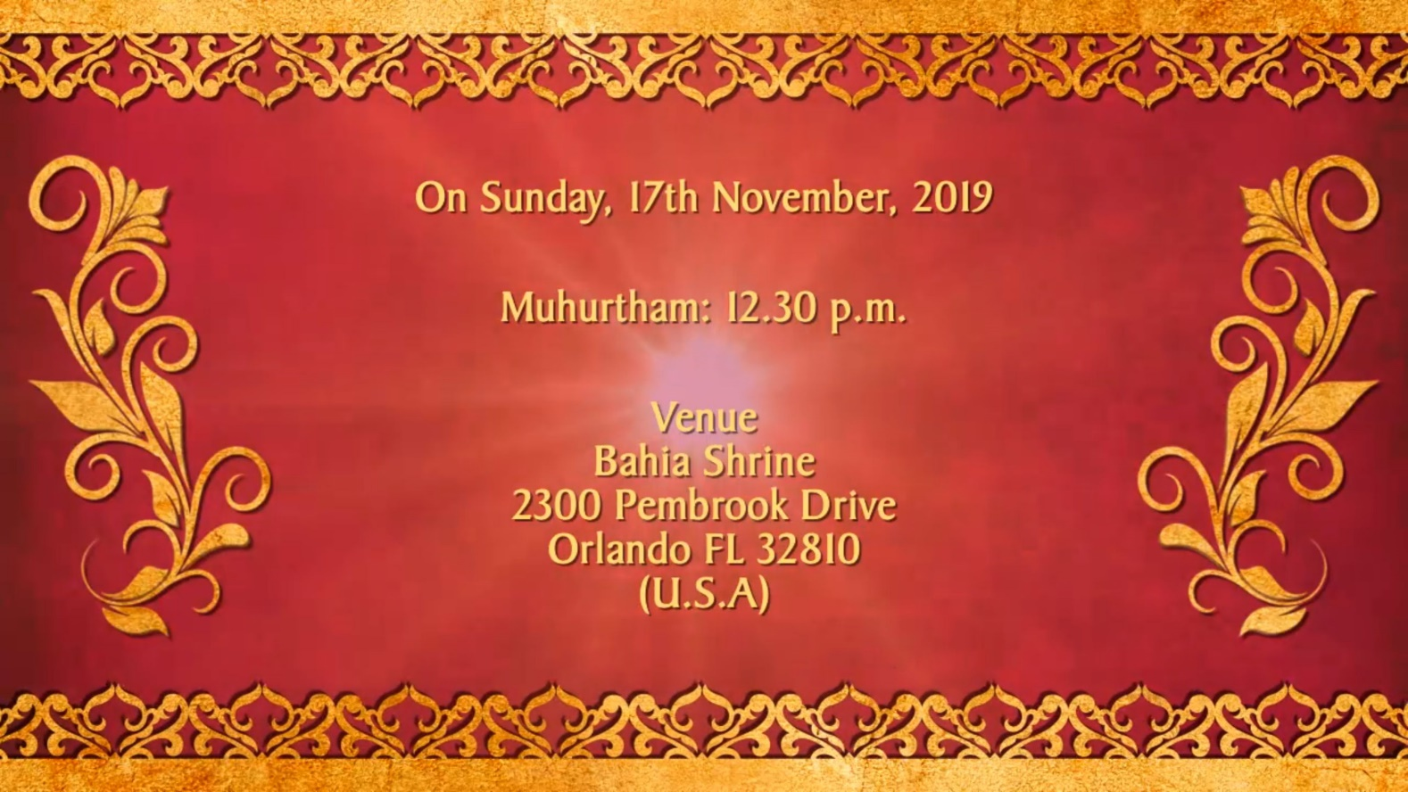

SLIDE-4
___________________________________
___________________________________
___________________________________
___________________________________
___________________________________
___________________________________

