DTC-Decorative Thread Ceremony

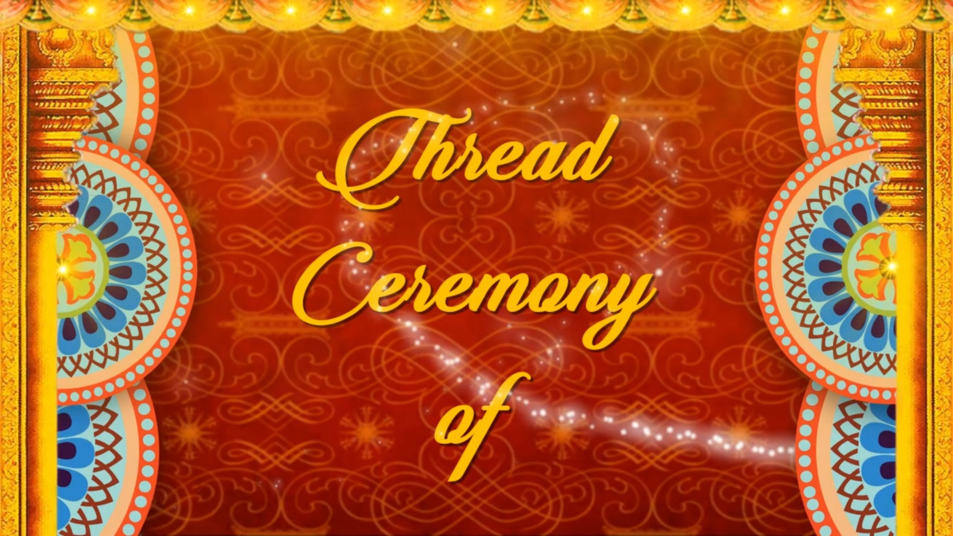

SLIDE-1
___________________________________
___________________________________
DTC-Decorative Thread Ceremony

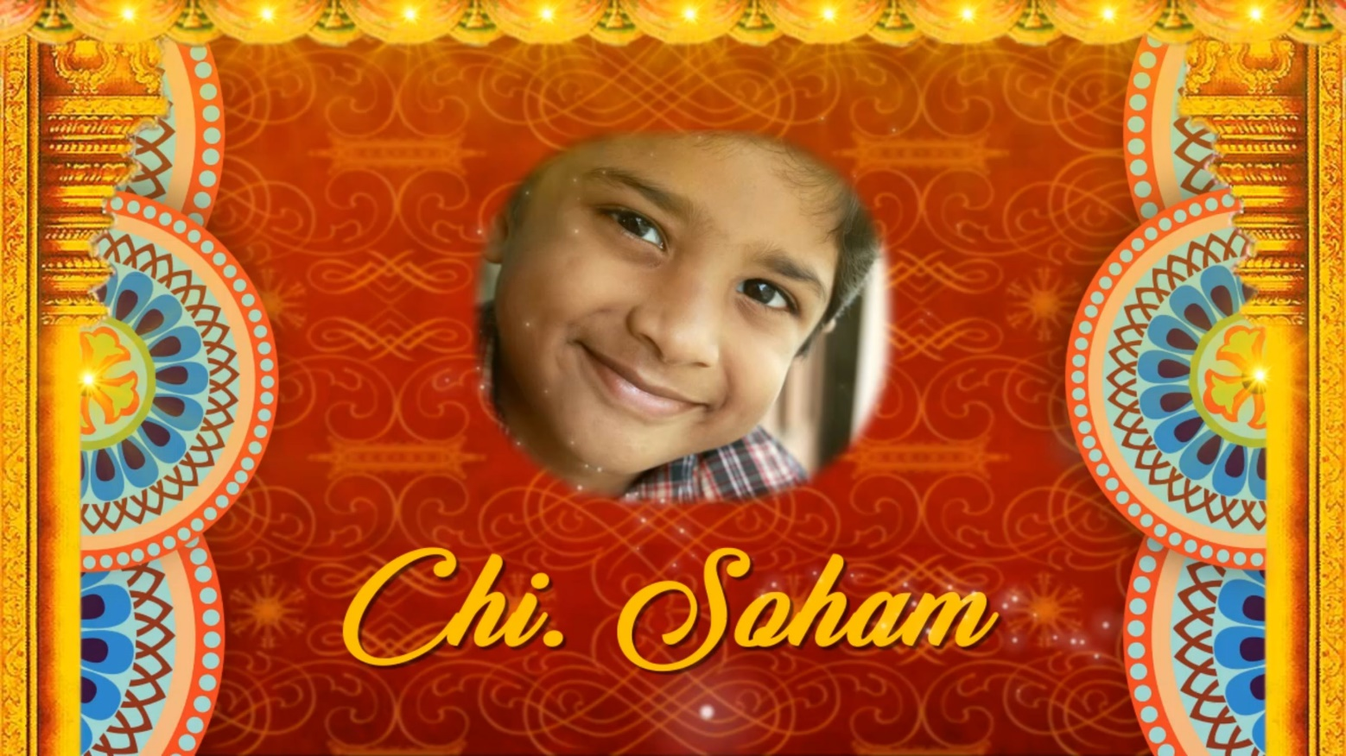

SLIDE-2
Attach High Resolution Image with email
___________________________________

DTC-Decorative Thread Ceremony

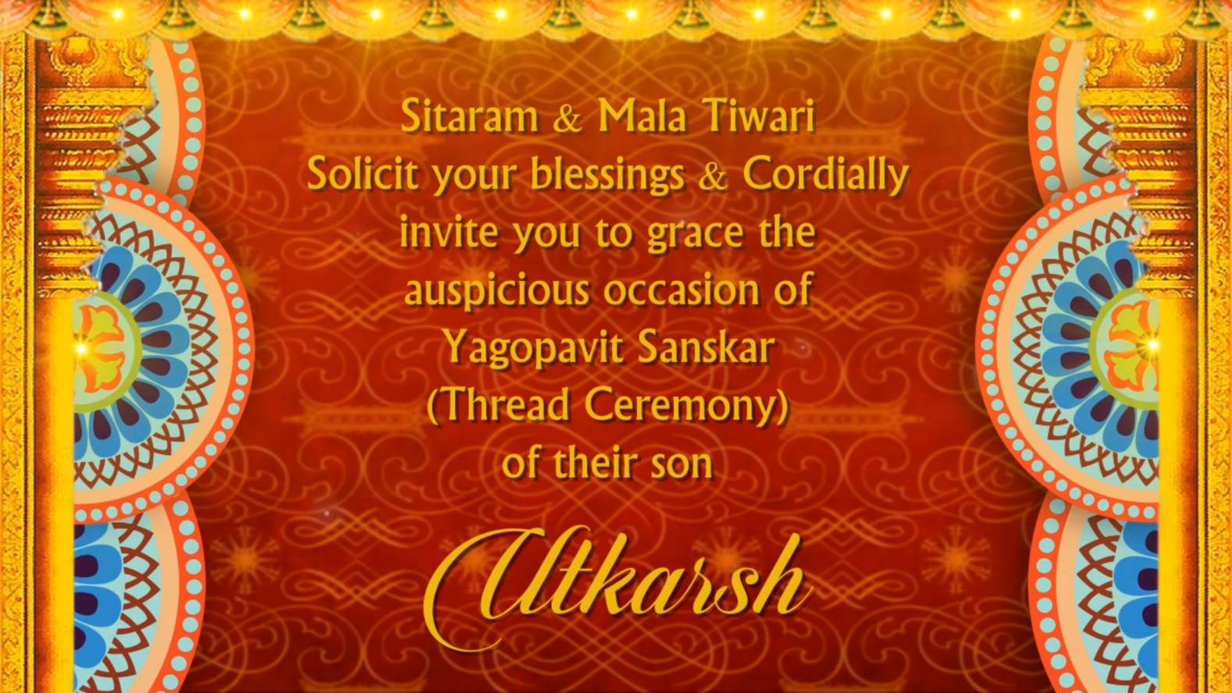

SLIDE-3
___________________________________
___________________________________
___________________________________
___________________________________
___________________________________
___________________________________

DTC-Decorative Thread Ceremony

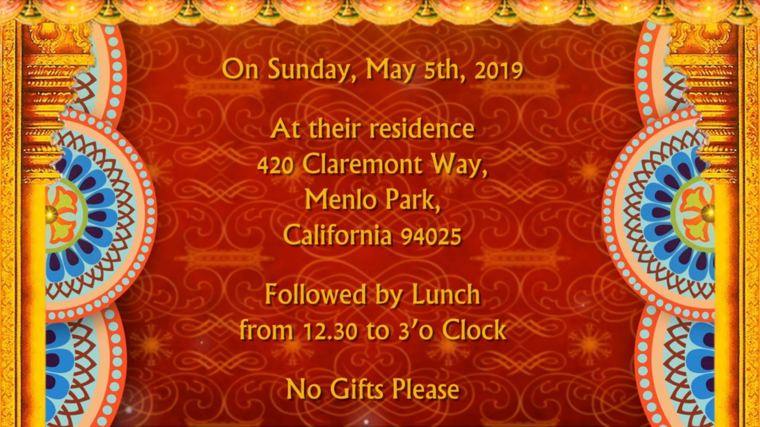

SLIDE-4
___________________________________
___________________________________
___________________________________
___________________________________
___________________________________
___________________________________

