DTC-Maple Leaf Invitation Marathi

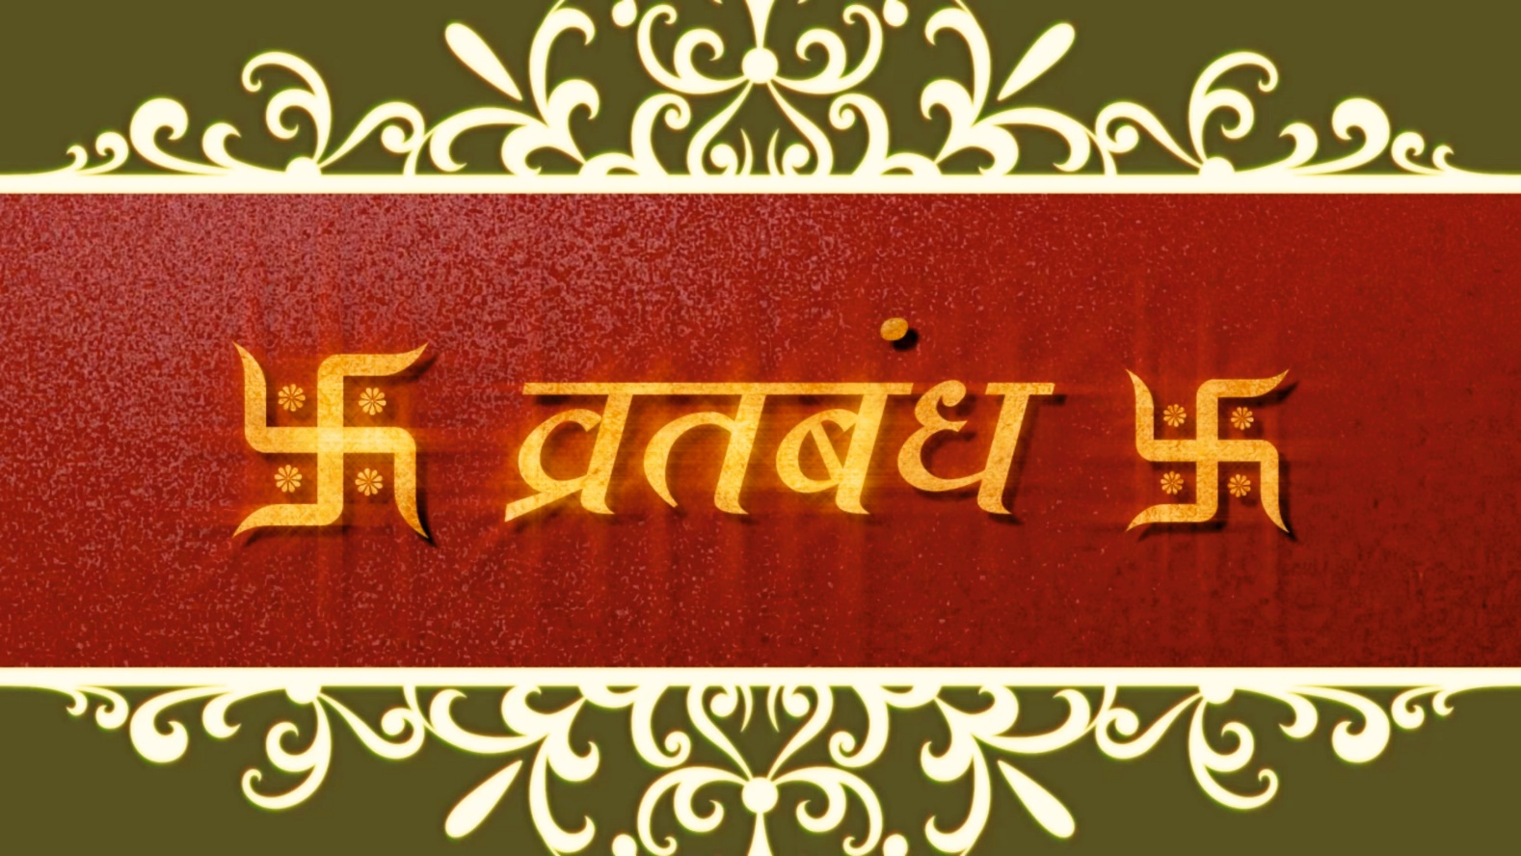

SLIDE-1
___________________________________
___________________________________
___________________________________
DTC-Maple Leaf Invitation Marathi

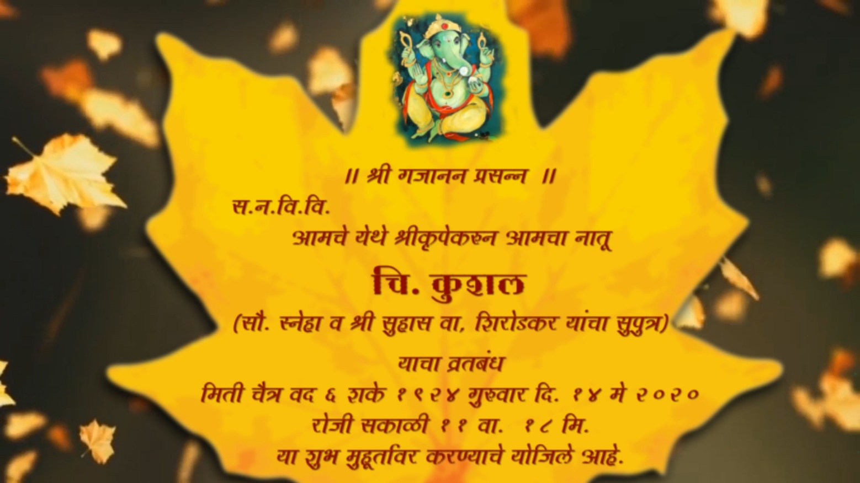

SLIDE-2
___________________________________
___________________________________
___________________________________
___________________________________
___________________________________
___________________________________

DTC-Maple Leaf Invitation Marathi

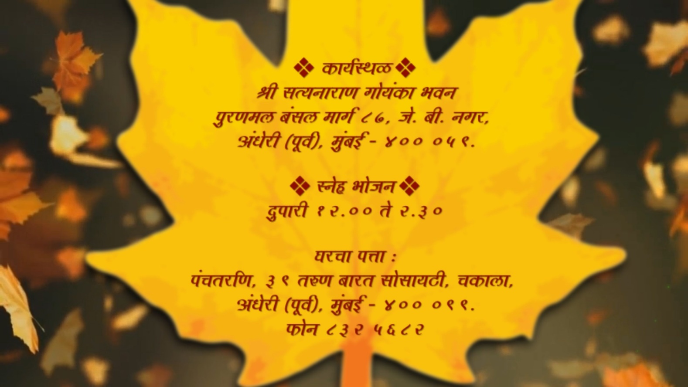

SLIDE-3
___________________________________
___________________________________
___________________________________
___________________________________
___________________________________
___________________________________

