DTC-Paisley-Pattern-English

SLIDE-1
___________________________________
___________________________________
___________________________________
___________________________________
DTC-Paisley-Pattern-English

SLIDE-2
Attach High Resolution Image with email
___________________________________
___________________________________

DTC-Paisley-Pattern-English

SLIDE-3
___________________________________
___________________________________
___________________________________
___________________________________
___________________________________
___________________________________
___________________________________

DTC-Paisley-Pattern-English

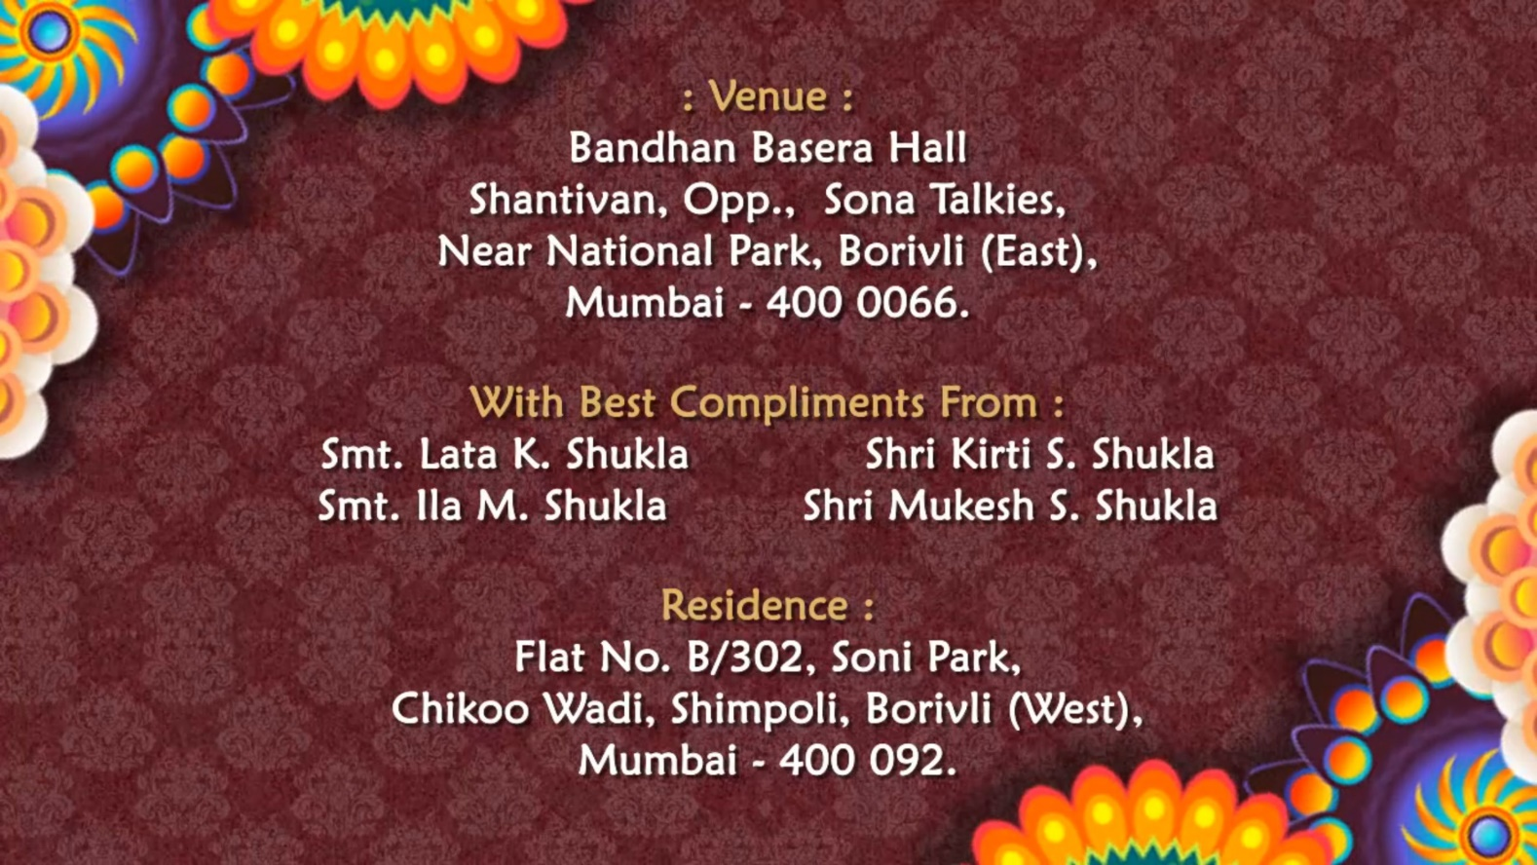

SLIDE-4
___________________________________
___________________________________
___________________________________
___________________________________
___________________________________
___________________________________
___________________________________

